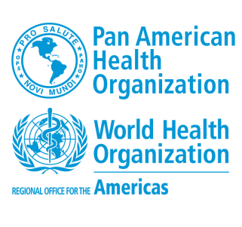 | APPLICATION FORM  Technical support of the EMT Regional Secretariat of the Americas  Regional Consultancy (IPC – P3) | 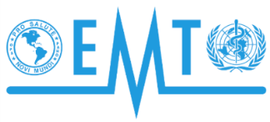

CONTACT INFORMATION
GIVEN NAME |  |  | FAMILY NAME
EMAIL |  |  |  |  | EMAIL 2
PHONE |  | MOBILE |  |  |  | SKYPE

REQUIREMENTS
Kindly reflect your working experience and accomplishments in the following fields. Please, be specific on the responsibilities you have undertaken to demonstrate your practical expertise according to the job requirements.
ESSENTIAL EXPERIENCE
Please, describe your working experience demonstrating at least five (7) years of combined national and international experience in Emergency Medical Teams or Disaster Response Teams.

DESIRABLE EXPERIENCE
Please, describe your theoretical knowledge and practical experience in the regional implementation of the global EMT initiative is desirable
Please, describe your knowledge of 911 systems, pre-hospital medical emergency systems
Please, describe your working experience in the coordination of Emergency Medical Teams response
EDUCATION
Bachelor’s degree in health sciences, in health sciences, social sciences, or a relevant field of the disaster response or health area, awarded by a recognized University.
Post graduate degree in a Master Level in Public Health, Emergency Health Services, or related field.
Other University degrees relevant to the required experience.
LANGUAGES

