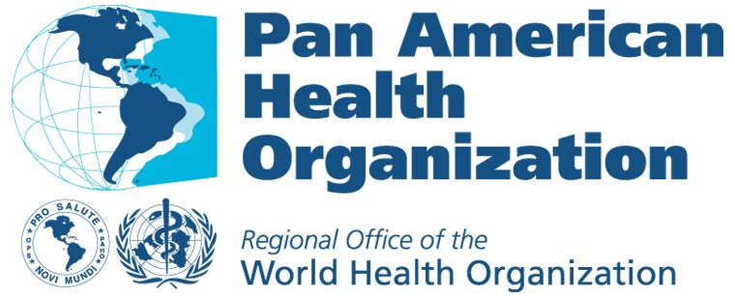

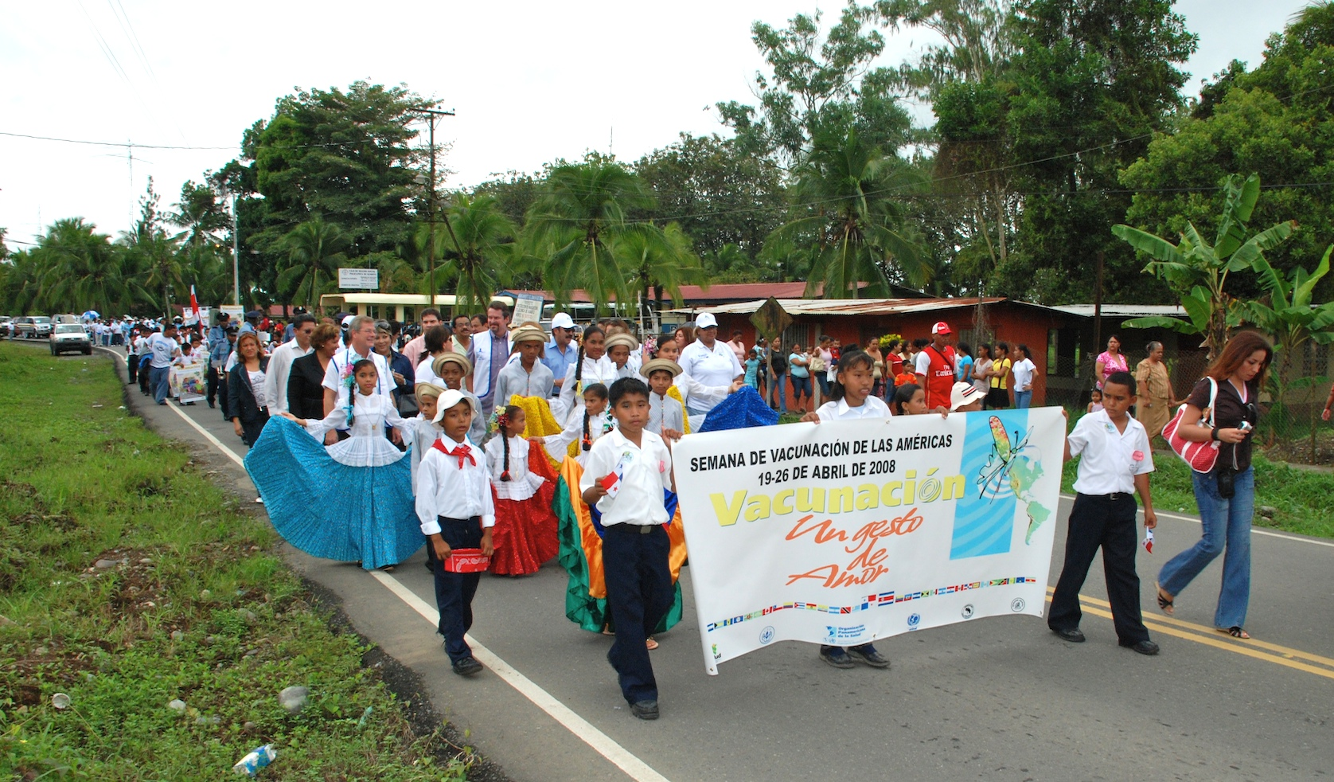
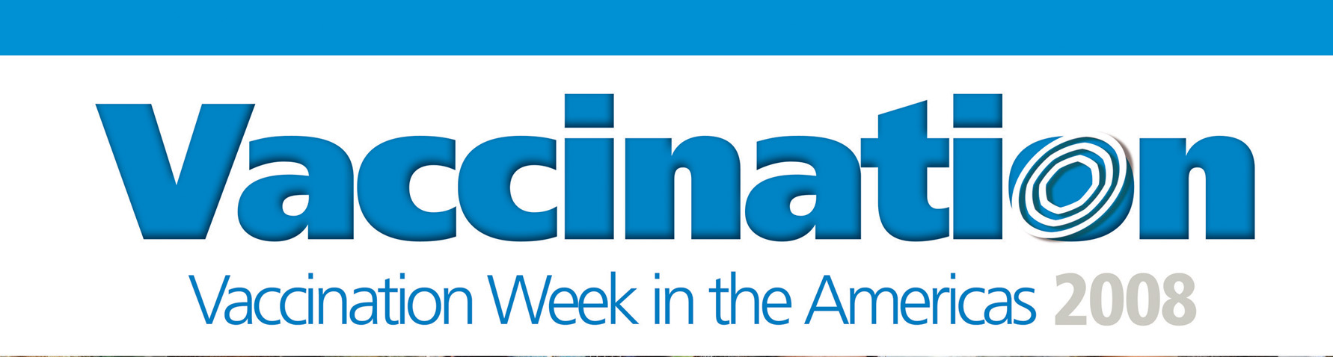

Comprehensive Family Immunization
Family and Community Health Area
Final Report
19-26 April 2008
Background

In 2008, Vaccination Week in the Americas (VWA) celebrated its six-year anniversary as an annual initiative to advance equity and access to vaccination and promote Pan Americanism. Prompted by a measles outbreak in Venezuela and Colombia, VWA was proposed in 2002 by the health ministers of the Andean Region. In September 2003, the week was officially accepted as a hemispheric initiative by the Directing Council of the Pan American Health Organization (PAHO) with the adoption of Resolution CD44.R1.

Since 2003, VWA has flourished in the Americas and has grown to include the participation of all countries and territories in the Region; over its tenure VWA activities have resulted in the vaccination of more than 250 million individuals (Figure 1). VWA strengthens the Expanded Program on Immunization by emphasizing activities that “reach the unreached”: those populations in rural and/or border areas, low coverage municipalities, urban fringes and in indigenous communities with limited contact to regular immunization services and at risk for contracting vaccine-preventable diseases. VWA also helps to raise population awareness of the importance of vaccination through the widespread media coverage it garners, as well as through the implementation of social communication and health promotion campaigns.

Figure 1. VWA Results by population group 2003-2008

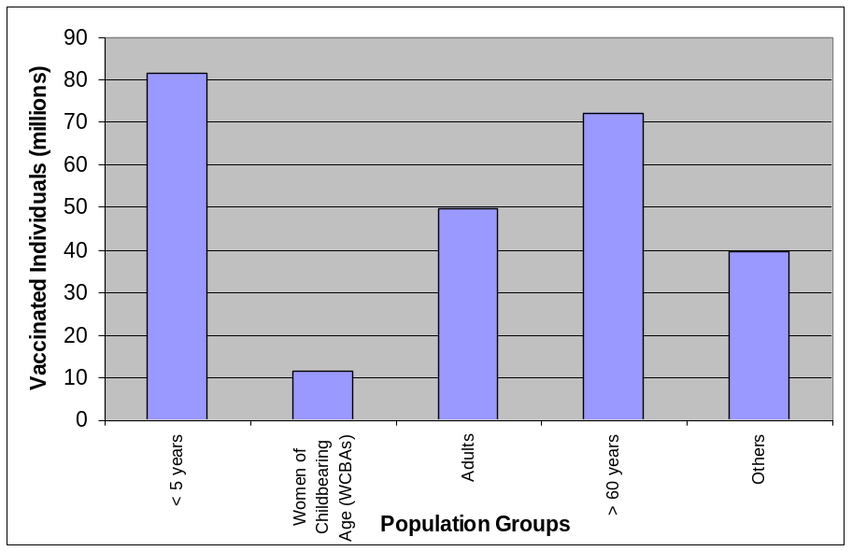
Total: 254,861,110

Source: Country Reports to FCH-IM, PAHO

Due to the flexibility of VWA, a wide variety of vaccination campaigns have been undertaken as part of the initiative. The week has also served as a platform for the introduction of new vaccines and as an opportunity to integrate other preventative interventions with vaccination (Table 1). Of note, in 2008, multiple VWA launching events took place along binational and trinational borders in the Region under the framework of a Health Caravan. These events counted on the participation of high-ranking authorities as well as local community leaders and illustrated the ability of VWA to transcend political borders in the name of public health.

Table 1. Summary of Goals and Achievements of Vaccination Week in the Americas, 2003-2008
Goals | 2003 | 2004 | 2005 | 2006 | 2007 | 2008
Rubella elimination |  | ECU, ELS | PAR | BOL | CUB, DOR, ELS, GUT, MEX, HAI | ELS, MEX
Measles follow-up campaigns | BOL, MEX, PAR | HON, NIC | ARG, SUR | URU, COL, MEX, VEN | COR, DOR, NIC, PAN, PAR | ECU, GUT, HAI, HON, MOT, NIC, PAN
Polio eradication | MEX, VEN | VEN | COL, CUB, DOR, HON, VEN | CUB, DOR, ELS, GUT, HON | HON, MEX, CUB, NIC | ECU, GUT, HON, NIC
Yellow fever risk reduction | VEN | VEN | COL, PER, VEN | COL, PER | BOL, ECU, PER, PAR | COL, PAR, SUR
Influenza prevention |  | BRA, CHI | BRA, PAN | ARG, BRA, CHI, PAN, PAR, URU | ARG, BRA, COR, COL, CHI, GRA, PAN, PAR | BRA, CHI, COL, PAR
Completion of schedules | VEN | CUB | GUT, BAH, COL | PER | COL, DOR, HON, NIC, PAN, PAR, PER, VEN | ANG, ELS, GRA, GUY, NIC, PAR, SUR, VEN
Tetanus control | MEX, VEN |  | COL, PAN | ECU, PAR | COR, NIC, PAR | BOL, COL, CUB, JAM, MOT, NIC, SCN
Introduction of new vaccines |  | DOR | GUT | PAN | COR ,GREN, PAN, VEN | CHI, ELS, PAN, URU
Interventions in indigenous communities |  |  | BRA | BRA | BRA, PAR | BRA, BOL, COL
Achievements | 2003 | 2004 | 2005 | 2006 | 2007 | 2008
Population vaccinated | 16,283,888 | 43,749,720 | 38,172,925 | 49,219,552 | 47,694,804 | 59,740,221
Participating countries and territories | 19 | 35 | 36 (12 with awareness campaigns) | 39 (16 with awareness campaigns) | 45 (8 with awareness campaigns) | 45 (12 with awareness campaigns)
Countries with integrated activities | 0 | 4 | 5 | 7 | 6 | 10
Mobilization of resources | 77,040 | 1,400,000 | 737,865 | 400,000 | 435,280 | 304,535
Source: Country Reports to FCH-IM, PAHO
VWA Planning and Strategy

Countries and territories in the Americas designate their own activities for VWA according to national health goals and current epidemiologic evidence. Planning for the week starts in the Region, with the support of PAHO, approximately 6-7 months prior to its launch. This period allows for the identification of target populations, the elaboration and dissemination of social communication materials, and for the mobilization and allocation of financial and human resources.

While target populations and antigens administered during VWA differ country to country, several notable strategies have been repeatedly used in the past six years and have contributed to VWA’s success. One strategy includes the implementation of extramural vaccination activities in locations such as educational facilities, community centers or work places, such as airports and farms. Additionally, mobile brigades of vaccinators are often employed during VWA to reach individuals living in difficult to access areas. Institutionalized vaccination is also often intensified during VWA due to its promotion through mass communication channels. Many countries in the Region, primarily in areas of the English-speaking Caribbean, the United States and Canada choose to use VWA to focus mainly on social communication and health promotion campaigns.

In 2008, VWA occurred from 19-26 April; however many countries extended this period in order to accommodate larger campaigns or to reach isolated populations. Table 2 illustrates the goals set for VWA from forty-five countries and territories by target population and according to sub-Region. The goal of vaccinating 62 million individuals is the largest posited thus far in the history of the initiative and incorporated multiple campaigns including measles/rubella elimination efforts, which took place primarily in the countries of Central America, as well as yellow fever control campaigns in South America.

Table 2. VWA 2008 Vaccination Goals by Target Population and sub-Region

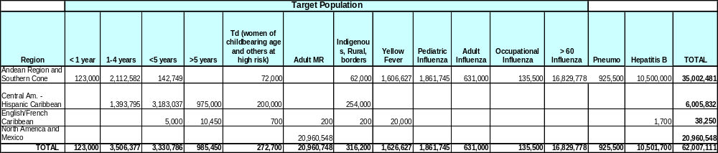
Source: Country plans of action received by April 2008.
VWA 2008

a. Border celebrations and the “Caravan for Health”

This year, VWA launching events brought the president of Panama, (Mr. Martín Torrijos), multiple Ministers and Vice Ministers of Health, PAHO’s Director, (Dr. Mirta Roses Periago), Mr. Nils Kastberg, Regional Director of the United Nations Children’s Fund (UNICEF) for Latin America and the Caribbean, Dr. Cesar Núñez, Regional Director of the Joint United Nations Programme on HIV/AIDS (UNAIDS) for Latin America, internationally known singers, (Ricardo Montaner, a UNICEF ambassador, and Jerry Rivera, a PAHO Champion for Health), and community leaders, among many others, to border areas throughout the Region. In particular focus were six consecutive launching events which took place from 19-24 April in border areas of the US/Mexico, Central America and Panama. These events were organized around the theme of a “Caravan for Health” and the accompanying slogan “Get on Board, Get Vaccinated” (Figure 2). Themes emphasized during the launching events included the need for cooperation across borders and solidarity between countries in order to prevent the spread of disease.

As part of the celebrations involving countries bordering Mexico, on 21 April, a lit torch was passed between the Mexican Secretary of Health, Dr. José Angel Córdova Villalobos and United States Health Authorities in El Paso, Texas and Sunland Park, New Mexico, with the participation of Dr. Roses Periago. This torch was subsequently brought to the launching events on the Guatemalan/Mexican border (23 April) and the Belize/Mexican border (24 April) and passed between Dr. Córdova Villalobos and Dr. Eusebio del Cid Peralta, then Minister of Public Health of Guatemala and Hon. Pablo Saul Marin, Minister of Health of Belize. All launching events included speeches from representatives from both sides of the border, cultural presentations and the participation of community groups, and symbolic vaccination by participating authorities (Photographs can be found in appendix 1).

Of particular note, Costa Rica expanded upon the concept of a Caravan for Health in their celebration of VWA and organized a national vehicular caravan which traversed the country from north to south on 21-25 April. This Costa Rican caravan began on the border with Nicaragua in the Canton of La Cruz and ended along the Panamanian border, in Río Sereno, where a binational closing event was celebrated. Along the way, the leadership of the caravan was passed off among Costa Rican health authorities who participated in a variety of celebratory events during the five-day journey.

In South America two trinational launching events for VWA were also celebrated in 2008. The first event was held on the “Tres Fronteras” area between Brazil, Colombia and Peru, on 19 April, and the second took place in Lethem, Guyana on 20 April with representatives from Guyana, Venezuela, and Brazil.

Figure 2. VWA Binational and trinational launching events, 2008.
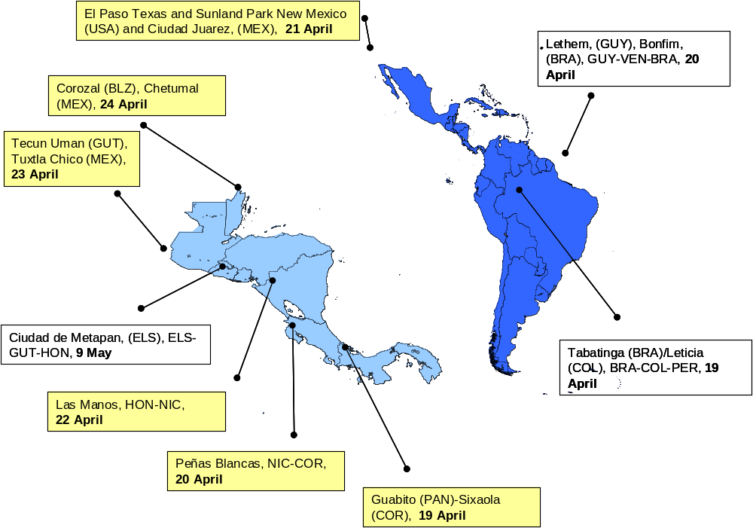

Events that took place under the framework of the “Caravan for Health”.
b. Vaccination Results

As of 29 October 2008, 36 countries and territories had reported the vaccination of 59,740,221 individuals through VWA 2008 activities, as well as the implementation of various social communication initiatives. The diverse vaccination efforts of countries and territories during VWA achieved approximately 96% of the established goal of 62 million individuals. These results can be categorized into the Regional Immunization Vision and Strategy; namely protecting the achievements, completing the unfinished agenda, and facing new challenges. Selected results are summarized below.

- Protecting the achievements: polio eradication, measles elimination, diphtheria and hepatitis B control, and completion of vaccination schedules.

- In 2008, VWA took place in the midst of multiple national measles follow-up campaigns occurring predominately in the countries of Central America. The numbers of individuals vaccinated during these larger campaigns were counted as part of VWA totals and included Honduras, Nicaragua, and Panama, who vaccinated 687,966 (preliminary data), 375,781, and 236,620 individuals, respectively, between ages 1-4 years with the MR vaccine. In Guatemala 1,853,536 children between ages 1-6 years were vaccinated with the MR vaccine, and in South America, Ecuador administered 1,765,154 doses of MR to children aged 1-6 years. In the Caribbean, Haiti also conducted measles elimination efforts during VWA.

- To maintain polio eradication in the Americas, Ecuador, Guatemala, Honduras, and Nicaragua also administered the oral polio vaccine (OPV) in addition to their measles campaigns. In Ecuador 1,968,313 doses were administered to children aged less than 7 years (preliminary data), in Honduras 882,170 children aged between 2 months and 4 years were given doses of polio vaccine (preliminary data), in Guatemala 1,168,813 children aged 1-4 years were vaccinated, and in Nicaragua 644,389 doses of polio vaccine were given to children aged less than 5 years.

- Occupational health was also a large focus during VWA this year. Many countries, especially throughout the English-speaking Caribbean, targeted population groups for vaccination and/or educational interventions whose occupation place them at heightened risk for vaccine-preventable diseases. Results include:

  - On the islands of St. Kitts and Nevis, health workers vaccinated farmers, and fishermen, administering 321 doses of Td and 662 doses of hepatitis B vaccine. St Kitts also organized multiple health education activities (talks, radio, and television programs) targeting these professions. As a result of VWA, 80.2 % of the farmers and fishermen on the island have been vaccinated against diphtheria and tetanus and 100% are now immunized against hepatitis B.
  - In St. Vincent and the Grenadines, a team of health workers visited the parliament and police station to discuss the importance of immunization and to administer Td, hepatitis B and yellow fever vaccines.
  - In Guyana, VWA initiatives included the vaccination of cane cutters and industrial workers.
  - In Peru, more than 9 million individuals were vaccinated with the first dose of hepatitis B vaccine during the initial stage of a nationwide, three-stage campaign taking place this year. The majority of the individuals vaccinated were aged 2-19 years; however, 326,728 health workers and other at risk populations also received the vaccine.

- Multiple countries used VWA to complete vaccination schedules, making a marked contribution to the Expanded Program on Immunization.

  - In Paraguay, where VWA was extended to take place from 28 April to 31 May 2008, the initiative boosted vaccination coverage of BCG by 9%, OPV and Pentavalent vaccine by 8%, MMR by 10% and the yellow fever vaccine by 6%, over the preceding months (Figure 3).
  - In Suriname, as part of VWA activities, the Regional Health Services clinics in the coastal area focused on reaching children aged less than 5 years marked as drop-outs in clinic registries. Due to efforts to search out these children with home visits and administer any necessary vaccines, 16 out of 39 participating clinics reached 100% coverage of children aged less than 5; one rayon, made up of 7 clinics, reported 100% coverage. This exercise also enabled Suriname to identify changes needed with respect to program coordination and information systems management.
  - In Nicaragua, in addition to the administration of MR and polio vaccines, the country administered the MMR, rotavirus, pentavalent and DPT vaccines, according to vaccine schedules. Finally, in El Salvador, VWA activities included the administration of all antigens. Of note, El Salvador vaccinated more than 10,000 adult men with the Td vaccine.

Figure 3. Contribution of VWA to increased vaccination coverage of the Regular EPI Program in Paraguay, 2008
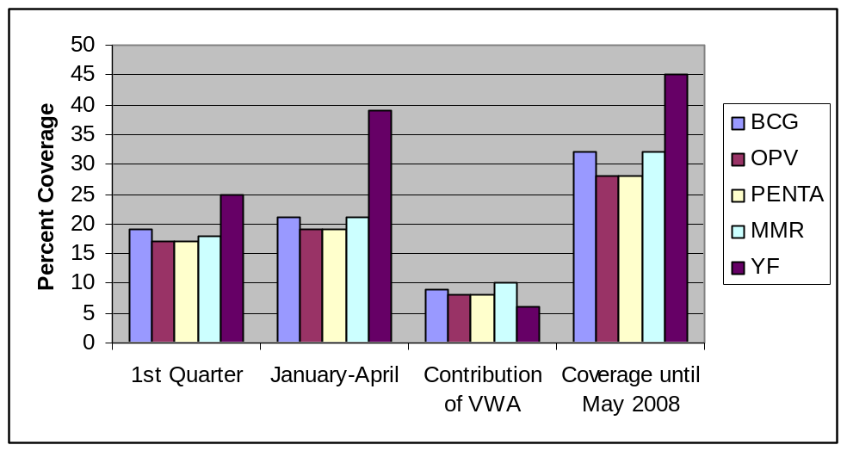
Source: presentation of the Ministry of Public Health and Well-being, Paraguay [preliminary data].

2. Completing the unfinished agenda: improving vaccination coverage against yellow fever, influenza, rubella and CRS, and maternal and neonatal tetanus in high-risk, isolated, border, and indigenous populations.

- In February 2008 a yellow fever outbreak occurred in areas of Paraguay, Argentina, and Brazil. This outbreak represented the first cases of yellow fever in Paraguay in more than thirty years. Additionally, several cases reported from the area around Asunción were confirmed as the urban cycle of the virus, the first such cases reported since 1942 in the continental Americas. This situation highlighted the need to maintain high vaccination coverage as well as to improve surveillance efforts and to engage in vector control efforts in the Region. As a follow-up to the outbreak, Paraguay made use of VWA to continue with a widespread yellow fever vaccination campaign, administering 947,044 doses of the vaccine to individuals aged 1-59 years, residing in municipalities with confirmed yellow fever foci and in border areas with Brazil and Argentina. In Suriname, the Bureau of Public Health engaged in yellow fever activities in the hinterland, as well as vaccinating special risk groups such as police, military, customs, health workers, and others in the coastal area.

- As in prior years, Brazil made use of VWA to conduct a massive seasonal influenza campaign, using the southern formulation of the vaccine, and targeting its population aged more than 60 years. Brazil’s efforts resulted in the vaccination of approximately 87% of this target group, or 14,057,291 individuals. Chile also vaccinated 2,924,779 individuals against influenza during VWA: target groups included adults over 60 years of age, individuals with chronic disease, children aged 6-23 months, pregnant women, health workers, and bird farmers. Paraguay also vaccinated 470,385 individuals with the influenza vaccine, including elderly adults, health workers and other risk groups and Colombia vaccinated 257,603 children aged 6-23 months with this vaccine.

- As part of VWA this year, both Mexico and El Salvador conducted rubella and congenital rubella syndrome (CRS) elimination campaigns. Mexico’s massive national campaign was undertaken throughout the months of March and April, vaccinating 22,197,056 individuals between the ages of 19-29 years. El Salvador focused on individuals between the ages of 12-18 years during its campaign throughout the month of April, immunizing 893,523 individuals with the MR vaccine, or 98.1% of the national goal.

- In terms of neonatal tetanus elimination, Cuba vaccinated 12,539 children with the DPT vaccine and 61,081 adults between the ages of 15-59 years with tetanus toxoid. Colombia administered 50,785 doses of Td to women of childbearing age (WCBAs), Nicaragua vaccinated 831,776 children aged 6-14 years, WCBAs and other risk groups with Td and Jamaica administered 4,606 doses of Td vaccine to adults, including WCBAs, health care workers, solid waste workers and farmers.

- As in prior years, the vaccination of border, indigenous, and other hard-to-reach populations was a priority for many countries during VWA 2008.

  - Panama conducted vaccination campaigns targeting communities along the border region with Costa Rica. These efforts reached 100% of the populations chosen according to a selected set of risk criteria and 8,977 doses of a wide variety of antigens were applied to improve coverage and update schedules. In Bolivia, vaccination activities focused on unvaccinated, hard-to-reach populations; the country administered a wide variety of antigens to children and 35,843 doses of Td to WCBAs. In Colombia, vaccination efforts prioritized municipalities in border areas, those with high unmet basic needs, populations displaced by the armed conflict, areas with vaccination coverage below 50%, and those in indigenous communities.
  - As part of the Month of Vaccination of Indigenous Peoples in Brazil campaigns focused reaching 15 of the most hard-to-access indigenous districts in the country, with the administration of more than 150,000 doses of vaccine, activities in 1,107 villages, and work coordinated by 96 field stations.

3. Facing new challenges: VWA has become a platform for new vaccine introduction. In 2008 results included:

- Uruguay used VWA as an opportunity to publicize the inclusion of the hepatitis A and pneumococcal vaccines into the national schedule through radio and television channels. In Chile, 1,133,558 doses of the pneumococcal vaccine were administered to adults aged greater than 65 years during the national influenza campaign. In El Salvador 4,368 doses of rotavirus vaccine were administered to children aged less than 6 months of age.

- During the VWA launching event held in Guabito, Panama, on 19 April, Panamanian Minister of Health, Dr. Rosario Turner, announced the introduction of the Tdap vaccine into the country’s national schedule, for adolescents at age 11 and health workers.

Table 3. People Vaccinated, by Target Population and Country or Territory, VWA 2008
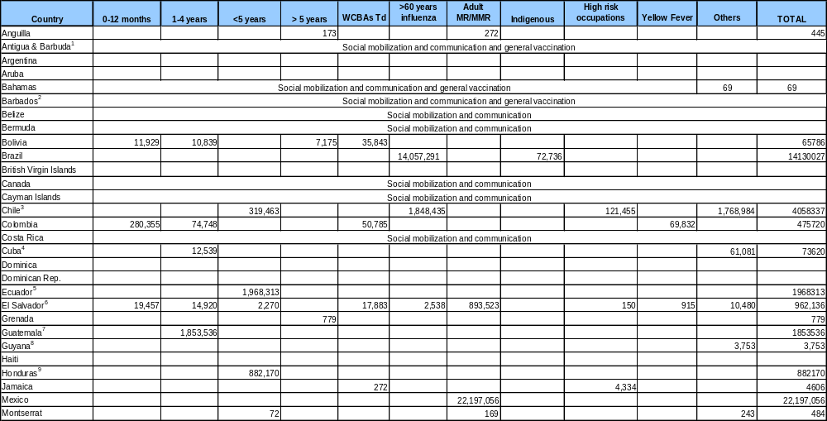

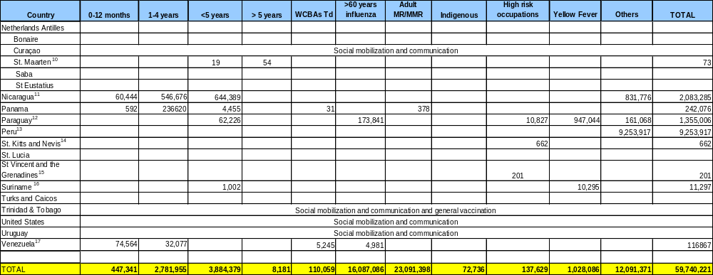
Source: Country Reports to FCH-IM, PAHO as of 29 October 2008
(1) Antigua and Barbuda administered a combined total of 275 doses of Td, MMR, hepatitis B, polio and influenza vaccines.
(2) Barbados vaccinated construction and agricultural workers with the Td vaccine and students in tertiary institutions with the varicella vaccine.
(3) High risk occupations include health workers and poultry farmers vaccinated for influenza. Others include individuals with chronic disease and pregnant women (as of the second trimester) vaccinated for influenza and pneumoccocal vaccination in adults aged ≥65 years.
(4) Individuals between 15-59 years of age vaccinated with tetanus toxoid.
(5) Preliminary data.
(6) MR/MMR data is for the month of April.
(7) Guatemala's campaign ran from 1 April to 16 June 2008 and the country administered the MMR vaccine to children aged 1-7 years and oral polio vaccine to children aged < 4 years.
(8) Guyana vaccinated populations in six of its 10 Regions across a wide spectrum of ages and using multiple antigens.
(9) Preliminary data.
(10) Groups vaccinated were aged 0-4 years and 4-17 years.
(11) Others refers to WCBAs, adult groups at risk, and elderly adults.
(12) Preliminary data. Others includes population groups vaccinated for influenza, including pregnant women (4,207) and individuals with chronic disease (47,838).
(13) Hepatitis B vaccination in population between the ages of 2-19 years.
(14) Farmers and fishermen.
(15) Police officers and parliamentarians. Includes 18 doses of yellow fever vaccine.
(16) Yellow fever data is preliminary, from May-July 2008. Suriname's yellow fever campaign runs until October 2008 and targets workers at risk and the population in the hinterland.
(17) TT given to pregnant women and Td given to WCBAs.

Table 4. Number of Doses Administered by Antigen and Country or Territory, VWA 2008 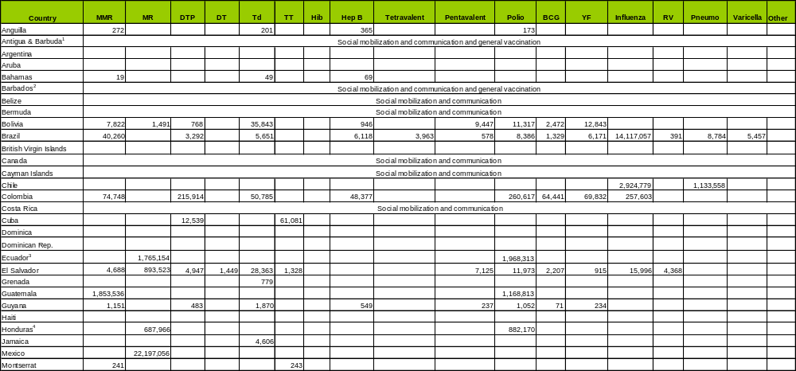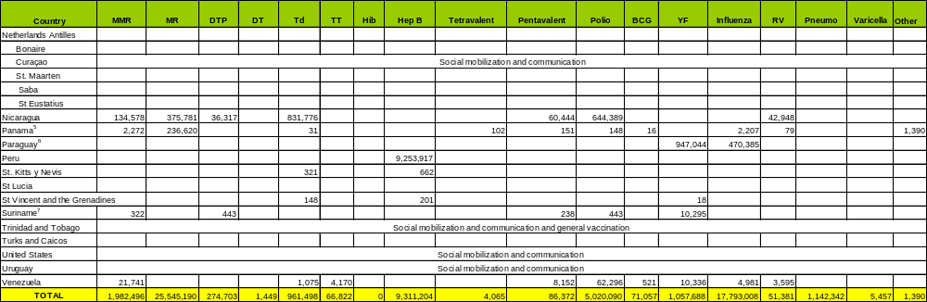
Source: Country Reports to FCH-IM, PAHO as of 29 October 2008
(1) Antigua and Barbuda administered a combined total of 275 doses of Td, MMR, hepatitis B, polio and influenza vaccines.
(2) Barbados vaccinated construction and agricultural workers with the Td vaccine and students in tertiary institutions with the varicella vaccine.
(3) Polio data is preliminary.
(4) Preliminary data.
(5) In Panama, 281 doses of hepatitis A vaccine were administered to populations aged 1-5 years. Additionally, 1,109 doses of Tdap were administered.
(6) Preliminary data.
(7) Yellow fever data is preliminary, from May-July 2008. Suriname's yellow fever campaign runs until October 2008 and targets workers at risk and the population in the hinterland.

c. VWA Indicators

As an additional way of documenting the impact of VWA, countries have defined the following indicators:

- Number and percentage of children aged 1-4 years with the first, second, and third dose of the DTP/pentavalent (to measure cases of 0 doses, delayed schedules, and completed schedules);
- Number and percentage of WCBAs in at-risk municipalities vaccinated with the first dose of Td during VWA;
- Percentage of rapid coverage monitoring (RCM) in municipalities with MR vaccination coverage <95%;
- Percentage of people interviewed in preselected areas who know about VWA;
- Percentage of municipalities with plans for a second and third round of vaccination to complete schedules after the VWA; and
- Number of suspect measles/rubella and acute flaccid paralysis (AFP) cases identified during active case-finding in the community and previously detected by the surveillance system.

In 2008, several countries made use of these indicators in their VWA reports. Results included:

- Along the Panamanian-Costa Rican border, out of a total population of 2,786 children aged 1-4 years, 20 children (0.7%) were given their first dose of DPT/Pentavalent, 27 children (0.9%) were given their second dose, and 34 (1.2%) were given their third dose. In Colombia 1,701, 1,639, and 2,313 children aged 1-5 years were given their first, second, and third doses of DPT, respectively, during VWA.

- In Honduras, 2,925 WCBAs were found with zero doses of Td during VWA activities. This number was higher then what had been anticipated, but this was thought to be due to loss of vaccination cards and re-vaccination. In the targeted border areas of Panama, 0.4% of WCBAs had not received a dose of Td or were unable to present their vaccination card.

- In Panama along the border, rapid coverage monitoring was conducted for the MMR, pentavalent, and rotavirus vaccines among children aged less than 5 years, as well as for the MR and Td vaccines in WCBAs. RCM among children found 100% coverage for MMR, 95.4% coverage for pentavalent and 64% coverage for rotavirus. Among women, coverage of 96.3% for MR and 98.6% for Td was documented. Active searches for suspected cases of vaccine preventable diseases were also conducted and none were found. In Honduras, as part of VWA and the national measles elimination campaign, 4,447 RCMs were conducted; 8% showed coverage rates lower than 95%. This information was used to readjust vaccination activities. Active surveillance activities in the country did not detect any suspected cases of measles/rubella or AFP.

- On the island of Grenada, results of interviews regarding knowledge of VWA indicated that 96% of individuals polled were aware of VWA and 71% of individuals had heard of VWA through the media. In St. Kitts, out of 98 individuals interviewed, 68.4% were aware of a special vaccination activity occurring and 41.8% had heard about the campaign through the radio. In Honduras, 93% of 1,509 mothers of children aged less than 5 years surveyed at vaccination posts had heard about the campaign through communication channels.

- In Colombia, all of the 1,118 municipalities in the country have scheduled a minimum of three extramural campaigns within their work plans in order to continue with the vaccination activities accomplished during VWA.

d. Mass communication and social mobilization activities

1. Regional campaigns and media coverage

In order to raise awareness of VWA in 2008, a multifaceted social marketing campaign was created by PAHO’s Office of Public Information. New messages were developed this year; however the traditional VWA slogan “Vaccination, an Act of Love” was also utilized. In total, 29,000 posters and 100,000 stickers were distributed throughout the Region. A CD with VWA design templates was also distributed; this resource allowed countries to readily adapt print materials to local languages and cultures, while still retaining the design features and logos used throughout the history of VWA social communication campaigns. Seven public service announcement (PSA) videos in Spanish, English, and Creole were also produced for use in national media channels.

Print materials

- As in 2007, this year PAHO continued its collaboration with the private sector in order to use the popular characters of Sesame Street in VWA materials. The image of a traditional bus together with the slogan “Get on Board, Get Vaccinated” was generated in accordance with the framework of a Caravan for Health.
- A second series of generic posters was also created, using diverse images of faces and the slogan “United for Health”

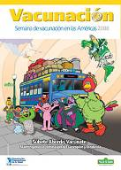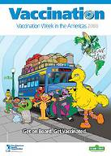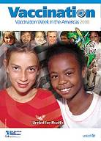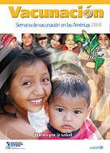
Examples of the print materials created for VWA 2008.

Videos

In 2008, VWA received the endorsement of the Director-General of the World Health Organization (WHO), Dr. Margaret Chan, when she taped a PSA in support of VWA and European Immunization Week with Dr. Marc Danzon, Regional Director of the WHO Europe office and PAHO Director, Dr. Mirta Roses Periago. As part of this video Dr. Chan commented that the objective of Vaccination Week to promote equity and access to vaccination is “extremely important and…in keeping with what WHO is doing. This is our core business, this is our core work.” Additional VWA PSAs were developed featuring basketball player Roger Mason of the Washington Wizards and internationally known singers Wyclef Jean and Ricardo Montaner. A PSA featuring the characters of Sesame Street was also created with the cooperation of the Mexican Health Secretariat.

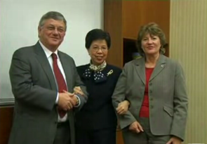
Dr. Marc Danzon, Regional Director, World Health Organization Regional Office for Europe (left), Dr. Margaret Chan, Director-General, World Health Organization (center), and Dr. Mirta Roses Periago, Director, Pan American Health Organization (right) in the final frame of their joint PSA video which promoted VWA, European Immunization Week (EIW) and advocated for work towards a Global Vaccination Week.

Media coverage

To disseminate VWA-related information, PAHO’s Office of Public Information prepared multiple news releases which were circulated in the weeks surrounding VWA. Outside media coverage of VWA was widespread throughout the Region and included articles published in the following news outlets:

Agence France Presse; Agencia EFE; British Virgin Islands News; El Comercio (Ecuador and Peru); Univision; Terra.com; El Universo; Milenio; Diario Los Andes; El Heraldo; El Mercurio; El Mundo (El Salvador); Miami Herald; La Nación (Paraguay); ABC Color; El Nuevo Herald; Portal Paraguayo de Noticias; Última Hora (Paraguay); Diario Digital Juárez; El Informador; Agencia Bolivariana de Noticias; El Carabobeño; Diario de Quintana Roo; La Nación Costa Rica; La Prensa (Nicaragua); Nueva Prensa de Guayana; RNV; El Nuevo Diario; El Panamá América; La Prensa (Panamá); Houston Chronicle; Diario La Estrella; El Paso Times; Globovisión; Estrella de Panamá; El Sol de Tijuana; El Sol de Zacatecas; El Sol de México; ReliefWeb; El Nuevo Diario (República Dominicana); AZprensa; Medical News Today; Cayman Net News; The North Bay; Genetic Engineering News; Cherry Creek News; Prensa Latina, Cuba; WebWire.

2. National social communication campaigns

In addition to the Regional VWA social communication campaigns, countries have been creative in instituting their own communication initiatives. Throughout the Caribbean, many islands used radio talk shows to inform the public about VWA. For example, this year panel discussions on vaccine-related issues were aired on Radio Anguilla as part of the program “Health Matters” and in the Bahamas the topic of immunization was discussed on the radio talk show “Joining Hands for Health.” In Curaçao, VWA related materials were adapted into Dutch and a link to the VWA website has been placed on the government’s website. In many countries alternative social communication messages were also used: “Be wise and immunize” in Montserrat; “Vaccination, safe protection, a right, a duty, of everyone” (Vacunacion, proteccion segura....un derecho, un deber, de TODOS) in Costa Rica, and “Don’t be late, be fully immunized in 2008” in St Vincent and the Grenadines.

e. Integrated activities

In 2008, countries and territories in the Region also made use of the opportunities generated through VWA to integrate other preventative and educational interventions together with vaccination. Efforts included:

- During the VWA launching event held on the border between Belize and Mexico on 24 April, two Mexican mobile health units offered preventative health services such as Pap smears, dental checks, and hypertension and diabetes screening to the border communities. This VWA launching event was also used as an opportunity to address dengue control through the elimination of breeding sites and insecticide and larvicide use.

- Panama administered 771 doses of vitamin A to selected groups along its border with Costa Rica, while Bolivia administered 3,744 doses of vitamin A to children aged less than 4 years. In Nicaragua, 191,910 children aged 6-23 months received a dose of vitamin A, and in Honduras vitamin A was administered to 36,464 children aged 6 months-1 year, 463,161 children aged 1-4 years, and 18,815 post-partum mothers.

- In addition to the administration of vitamin A, Nicaragua distributed 1,318,837 doses of the anti-parasite medication Mebendazol to children aged 2-12 years. Honduras also distributed educational information about the early detection of eye cancer to parents of children aged less than 5 years of age and conducted dengue control activities.

- In St. Maarten, during a Vaccination Open House to check the immunization status of children, diabetes screening for accompanying parents was provided by the Diabetes Foundation.

- In Montserrat, the Sri Lankan community was screened for tuberculosis through application of the Mantoux test (PPD) as part of the activities on the VWA agenda.

- In Colombia, VWA activities occurred in conjunction with the celebration of the Month of the Child, necessitating intersectoral and interinstitutional coordination.

- In addition to the vaccine-related initiatives with farmers and fishermen on the island of St. Kitts and Nevis during VWA, radio programs during the week covered other health topics of interest to these professions including injuries and disorders of organ systems (occupational ergonomics), work-related stress issues, hazardous exposures (chemicals, pesticides and biological agents), and the management of livestock.

VWA in a global context

"We take pride not only because we can ensure that our children will be protected against vaccine- preventable diseases, but also because this week enables us to reinforce our commitment to work in unity and love with our sisters and brothers in the Americas."
--Minister of Health and Community Services, Montserrat

As VWA has grown over the last six years, the initiative has emerged as a positive force in the promotion of public health diplomacy in the Americas. Guided by VWA’s strategic framework to “reach the unreached,” countries have been able to link and advance both public health and foreign policy objectives through the implementation of vaccination activities along bi- and tri-national borders. In many countries VWA activities have also required collaboration between multiple governmental sectors such as health, labor, and education, in addition to support from multiple international agencies. In 2008, a formal follow-up statement encouraging participation in VWA activities was signed by PAHO’s Director, Dr. Roses Periago, as well as the Regional Directors for Latin America and the Caribbean of the United Nations Development Programme (UNDP), the United Nations Children’s Fund (UNICEF) the United Nations Population Fund (UNFPA), the United Nations World Food Programme (WFP), the International Labour Organization (ILO), The Joint United Nations Programme on HIV/AIDS (UNAIDS), the Economic Commission for Latin America and the Caribbean (ECLAC) and the United Nations Office for the Coordination of Humanitarian Affairs (OCHA). This statement was sent out to the above agencies’ country representatives.

In addition to strengthening collaborative efforts in Latin America and the Caribbean, VWA has been successful in placing disease prevention and health promotion high on political agendas. This fact was evident in 2008, when the president of Panama, Martín Torrijos, traveled to the border of Panama with Costa Rica, not in response to an emergency, but to support the launch of VWA, a week dedicated solely to acts of disease prevention and health promotion.

In other areas of the world, Europe celebrated the third annual European Immunization Week (EIW) in 2008, an initiative modeled after the success of the Americas. This year, 33 countries participated in this sister initiative, whose timing overlapped VWA. On 23 April, an EIW launching event was held in Ljubljana, Slovenia, with the participation of Her Royal Highness Crown Princess Mary of Denmark and the First Lady of Slovenia, Mrs. Barbara Miklic Turk. Of note, EIW was recently nominated for a 2008 European Health Forum Award, given to “public initiatives that have contributed in a significant way to meet health challenges and ameliorate disparities in health services provision in Europe”. As an overseas department of France, French Guiana participated in EIW in 2008. There are plans to link VWA and EIW again in 2009 as well as growing interest from other Regions of WHO, leading to a potential Global Vaccination Week in the near future.

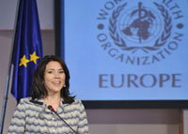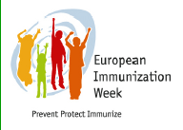
Her Royal Highness Crown Princess Mary of Denmark
at the EIW launch event, 2008.
Source: http://www.euro.who.int/vaccine/eiw/20080425_4

Moving forward, it will be important for the success of future VWAs that countries and territories continue to value this initiative not as just another yearly campaign, but instead as an opportunity to renew commitment to national immunization programs, help assure that such programs are given high political priority, and continue to work across national borders. Historically, documentation of the full impact of VWA has been challenging due to the diverse campaigns and strategies utilized in the Region. Countries are therefore also encouraged to collect data regarding the costs and benefits of their future efforts to “reach the unreached” through Vaccination Week in the Americas.

Appendix 1: Selected photographs from the diverse launching events held during VWA 2008
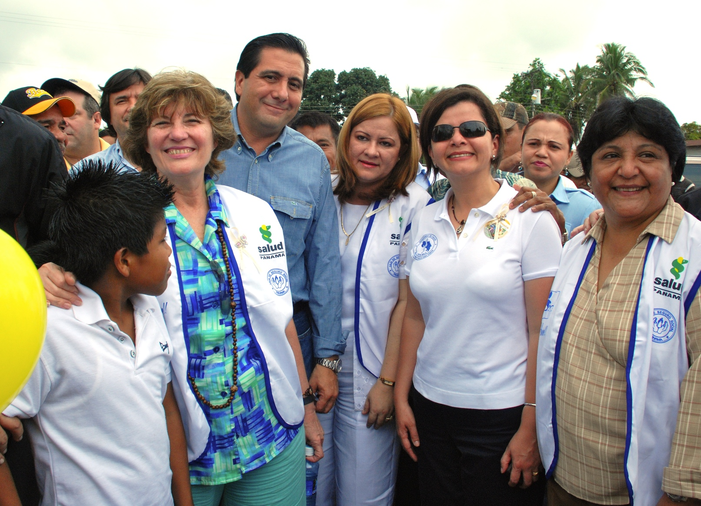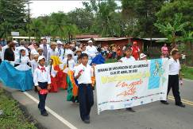
(L to R) Dr. Mirta Roses Periago, PAHO Director; Mr. Martín Torrijos, President of Panama; Dr. Rosario Turner, Minister of Health, Panama; and Dr. María Luisa Ávila Agüero, Minister of Health, Costa Rica among others, in Guabito, Panama.

A parade held during the launch of VWA along the border between Panama and Costa Rica.

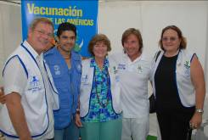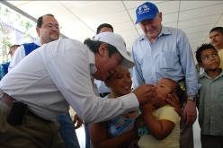
(L to R) Nils Kastberg, Regional Director of UNICEF for Latin America and the Caribbean; Mr. Jerry Rivera, artist and PAHO Champion for Health; Dr. Mirta Roses Periago; Ricardo Montaner, artist and UNICEF ambassador; Dr. Guadalupe Verdejo, PAHO Representative, Panama in Guabito, Panama.

The Minister of Health of Nicaragua, Dr. Guillermo González González, administers a vaccine while Dr. José Romero Teruel, then interim Assistant Director, PAHO, observes at the VWA launching event along the border between Costa Rica and Nicaragua.

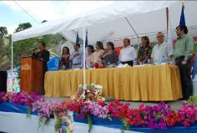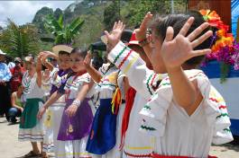
The head table at the VWA launching event along the border between Nicaragua and Honduras. Pictured are health authorities from both countries and representatives from the CDC and PAHO.
Children perform a traditional dance along the border between Nicaragua and Honduras.

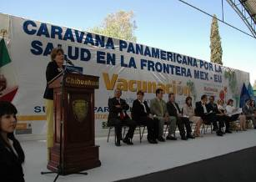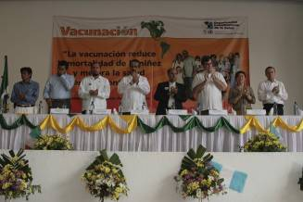
The head table at the VWA launching event in Tecún Umán, Guatemala. Pictured are local leaders, Guatemalan and Mexican health authorities and representatives from PAHO.
PAHO’s Director, Dr. Mirta Roses Periago addresses the audience at the VWA launching event in Ciudad Juarez, Mexico.

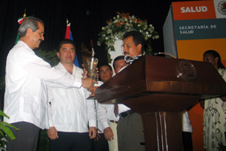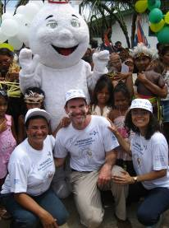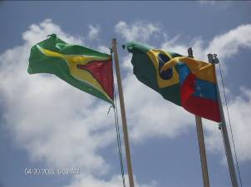
The Secretary of Health of Mexico, Dr. José Angel Córdova Villalobos passes a lit torch to Hon. Pablo Marin, Minister of Health, Belize, along the border shared by these two countries.
The national flags of Guyana, Brazil and Venezuela seen at the VWA launching event between these three countries.
Health authorities and a representative from
PAHO pose at the VWA event between Brazil, Colombia and Peru.

Global Immunization News, 27 August 2008 http://www.gavialliance.org/media_centre/publications/gin.php

