Steps for Monitors to Validate “The Switch”
2 week validation period following the National Switch Day
Preparation- Before National Switch Day
1. Receive list of cold chain stores and service points to visit from coordinator/supervisor
2. Develop micro-plan for visit schedule to sites (transportation, contacts, monitoring tools)
3. Retrieve Independent Monitoring Data Collection Tool (Form 1) to record each site visited
Visit Stores- 2 week validation period following National Switch Day
1. Ask staff at site to show you the vaccine storage equipment
2. Identify where the tOPV is located (inside or outside of cold chain)
If tOPV vials found inside cold chain:
- Remove tOPV vials
Label and remove tOPV for disposal!
- Keep vials in a plastic bag, labelled with
information on: number of vials, the store
vials were found, and the date of collection
- Corrective action: Return vials to disposal site or coordinator
- Record findings on Form 1
If tOPV vials found outside of cold chain:
- Verify if in a disposal bag with appropriate label (eg, Do not use. Destroy)
- Record findings on Form 1
3. Check for bOPV in cold chain
4. Check for IPV in cold chain
5. Record the number of excess tOPV vials at facility based on the stock ledger, number disposed, methods used for the disposal of tOPV
6. Determine if a follow-up visit is needed for the site
Report Findings- Check-in daily with supervisor
1. Report results daily either in-person or by phone to monitoring coordinator/supervisor
2. Complete any follow-up visits as requested
3. Submit Independent Monitoring Data Collection Tool (Form 1) to monitoring coordinator/supervisor upon completion of assigned Monitoring
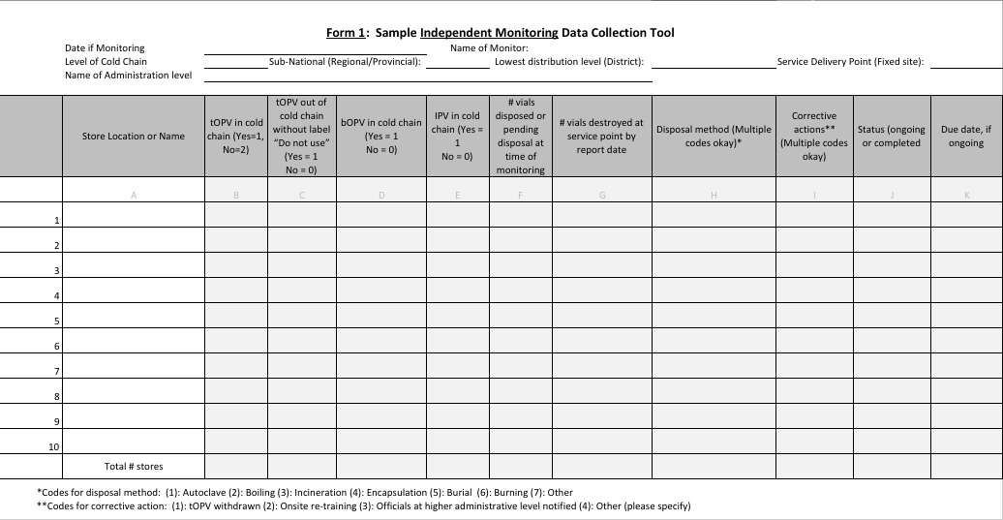

 | Store Location or Name | tOPV in cold chain (Yes = 1  No = 0) | tOPV out of cold chain without label “Do not use” (Yes = 1  No = 0) | bOPV in cold chain (Yes = 1  No = 0) | IPV in cold chain (Yes = 1  No = 0) | # vials disposed or pending disposal at time of monitoring | # vials destroyed at service point by report date | Disposal method (Multiple codes okay)* | Corrective actions** (Multiple codes okay) | Status (ongoing or completed | Due date, if ongoing
 | A | B | C | D | E | F | F | G | H | I | J
1
2
3
4
5
6
7
8
9
10
 | TOTAL # stores

